Solution for Problem 2 (Using ER Assistant Software for creating the diagrams)

Given ER Diagram:

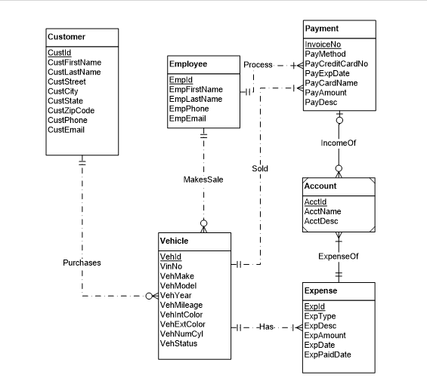

1. ***Vehicle*** entity is not having attribute for Transmission Type(automatic or manual)
2. In MakeSale relationship between ***Employee*** and ***Vehicle***, minimum cardinality near Employee should be zero as VehicleDetails can be recorded without an employee.
3. ***Account*** should not be a weak entity.
4. *IncomeOf*relationship between ***Payment*** and ***Account*** should be (1,1) near ***Account***, and (Optional, many near ***Payment***),it should be made non-identifying. (Reversed Relationship)
5. *ExpenseOf*Between ***Account*** and ***Expense*** should be (1,1) near ***Account*** and (Optional, Many near ***Expense***),it should be made non-identifying.(Reversed Relationship)
6. *Sold cardinality*near ***Payment*** should be zero. ***Vehicle*** can remain for a lot of days before sale.
7. *Purchases cardinality*should be zero near customer as vehicle is in stock for a lot of days before sales.
8. *Process*relationship between Employee and Payment does not mean anything.

